**Accelerated carbonation treatment of recycled concrete aggregates using flue gas: A comparative study towards performance improvement.**

Yunhui Pu , Lang Li , Qingyuan Wang , Xiaoshuang Shi , Ling Fu, Guomin Zhang , Chenchen Luan , Abd El-Fatah Abomohra

https://doi.org/10.1016/j.jcou.2020.101362

* Materials:

1. The 28-day compressive strength of the parent concrete was 49.3 ±2.5 MPa. After 90 days of water curing, the concrete specimens were manually crushed.
2. Obtain the RCAs with particle sizes between 5 mm and 20 mm.
3. Portland cement, NAs (5–20 mm), river sand (portland cement, NAs (5–20 mm), river sand sand (sand (<5 mm), and superplasticizer (SP) were also utilized to prepare the concrete mixtures.
4. Flue gas obtained from a cement plant was utilized as CO2 source in the present study.
5. The average CO2 concentration in flue gas was approximately 20 ±1.3 %. Except for CO2, other gases such as N2 (52.2 %), O2 (7.5 %) and H2O (19.1 %) were also detected in the flue gas.
6. The commercial compressed pure CO2 (100 %).
7. air with a CO2 content of 0.03 % were also used in this study.

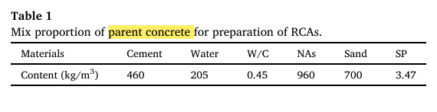

* Accelerated carbonation processes:

1. A steel chamber (with a working volume of 40 L) was designed for accelerated carbonation.
2. Gas flow rate (0.1 10 L/min) of the chamber was controlled by the flow control valve equipped at the gas inlet.
3. Humidity of the gas (approximately 50 %) was adjusted by a saturated solution of Mg(NO3)2 in the humidity controller unit.
4. Temperature and relative humidity in the chamber was 25 ±3 ◦C and 50 ±2%
5. carbonation processes, the collected RCAs were preconditioned in a drying chamber for 7 days. The temperature and relative humidity (RH) in the drying chamber were 25 ±3 ◦C and 50 ± 5%, respectively.
6. RCAs (approximately 5 kg)
7. total gas flow rate of 5 L/min for 7 days
8. CO2 concentrations (0.03 % (air), 5 %, 10 %, 20 %, 40 %, 60 %, 80 % and pure CO2 gas (99.9 %)) in the mixed gas were controlled by mixing a specific amount of air and pure CO2 gas.
9. different gas flow rate (0.5, 1, 3, 5 and 7 L/min)

* Concrete incorporated with RCAs

1. the concrete mixture was also prepared with the same w/c ratio as the parent concrete
2. The NAs were replaced by the same weight of non-carbonated RCAs and carbonated RCAs.
3. non-carbonated RCAs and carbonated RCAs have higher water absorption than that of NAs, extra water was supplied
4. Fresh concrete mixtures were casted into the 100 ×100 ×100 mm and 150 × 150 ×600 mm cubic molds, respectively.
5. After 24 h, the concrete specimens were demolded and cured in water at 20 ±3 ◦C for 28 days before compressive and flexural strength testing.

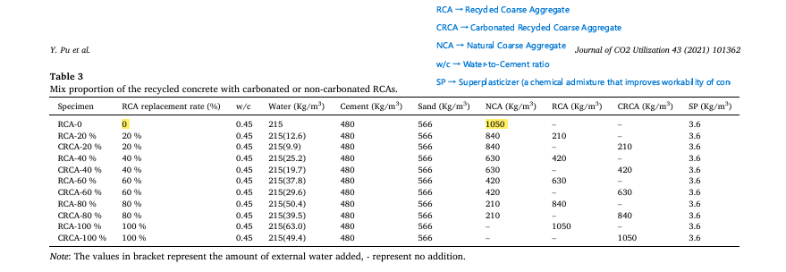Analysis methods:-

1. Characteristics of the RCAs Both non-carbonated and carbonated RCAs were obtained and pretreated before the tests. The physical properties of RCAs, including water **absorption, apparent density and crush value** were tested according to the Chinese standard JGJ/52-2006.
2. The carbonation extent of RCAs is defined as the ratio of the experimental determined mass gain to the theoretical mass gain of RCAs during the carbonation reaction.
3. Thermal gravimetric (TG) analysis , the amount of bound water, calcium hydroxide and calcium carbonate in RCAs were explored ac cording to the variations of TG results.
4. Fourier transform infrared (FTIR) analysis , To investigate the components of RCAs, cement paste samples from the non-carbonated RCAs and carbonated RCAs were analyzed using FTIR.
5. X-ray diffraction (XRD) analysis The samples utilized for XRD analysis were same as those for FTIR analysis.
6. Flowability and dry shrinkage of concrete incorporated with RCAs.
7. Mechanical properties of RAC ; the compressive strength of concrete , flexural tensile strength

**Development of a new generation of eco-friendly concrete blocks by accelerated mineral carbonation**

Dongxing Xuan, Baojian Zhan, Chi Sun Poon

<http://dx.doi.org/10.1016/j.jclepro.2016.06.062>

Materials:-

1. Coarse natural granite aggregates (5-10 mm),
2. river sand (<5 mm)
3. coarse recycled concrete aggregates (CRCA, 5-10 mm),
4. fine recycled concrete aggregates (FRCA, <5 mm),
5. a type of ASTM Type I Portland cement and tap water were used for the fabrication of the concrete blocks.
6. The RCA was obtained by crushing a designed Grade 45 concrete, which was produced by a local ready mixed supplier and cured on site for 6 months.
7. The crushed RCA was firstly carbonated in batches for 24 h in the
8. carbonation chamber at a pressure level of 5.0 Bar

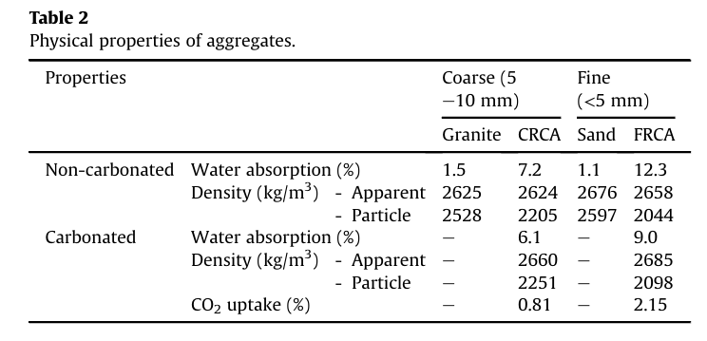

Mixture design of concrete blocks

1. the concrete block mixtures were prepared with the addition of 20% cement and 5.6% water (by the total mass of cement and aggregates
2. The replacement percentage of granite and sand by CRCA and FRCA was from 0% to 100% by mass
3. The mix of No. 13 with bold was designed with 50% replacement of natural aggregates by the total mass of aggregates.
4. , the total content of RCA including FRCA and CRCA was designed from 20% to 80% of the total mass of aggregates.

fabrication of concrete blocks

1. The fresh mixture was then filled into steel block moulds with internal dimensions of 200*100*60mm and 225*105*75mm
2. casting process, the freshmixturewas put into themouldsin three layers of approximately equal mass
3. each layer was filled, precompaction was applied manually using a hammer.
4. After the third layer was laid, a load of 600 kN at a rate of 10 kN/s by a compression machine was applied to compact the mixture. After reaching the maximum load, the load was kept for 30 s.

Accelerated mineral carbonation:

1. airtight steel-cylindrical chamber with a volume of approximately 100 L
2. maximum gas pressure of 5.0 Bar
3. Before CO2 gas was injected, the chamber had been vacuumed to 0.6 Bar by a vacuum pump
4. . A commercially sourced CO2 gas (>99.5% purity) was then injected to the chamber and the chamber pressure was controlled by a gas regulator to attain the required pressure level for a specific period.
5. carbonation chamber was used to carbonate the demolded concrete blocks for different time periods (1, 2, 3, 6, 18 and 24 h) at two different pressure levels (0.1 Bar and 5.0 Bar).
6. In order to increase the CO2 sequestration, all samples were firstly preconditioned in an environmental chamber with a constant temperature of 25 C and a relative humidity of 50% for 6 h

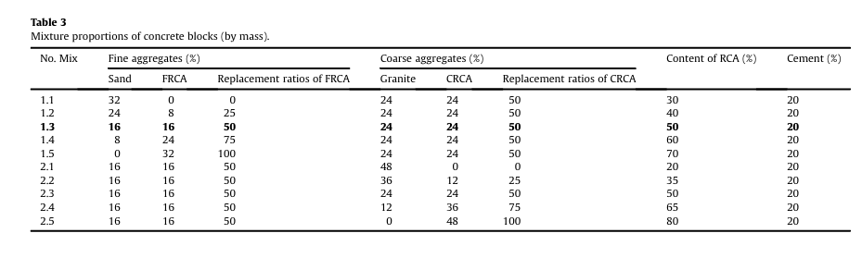

To Determine properties:

* CO2 uptake of aggregates and concrete blocks.
* Mechanical properties of concrete blocks – Compressive strength and Bending strength.
* Drying shrinkage of concrete blocks.

**The effects of carbonation conditions on the physical and microstructural properties of recycled concrete coarse aggregates**.

Asghar Gholizadeh-Vayghan , Annelie Bellinkx , Ruben Snellings , Bram Vandoren , Mieke Quaghebeur

https://doi.org/10.1016/j.conbuildmat.2020.119486

C&D

**Whole procedure of C&D :-**

1. A base concrete mixture is first produced, cast and cured inside sealed plastic buckets for production of RCA. After 28 days, the concrete is first crushed into hand-sized rubbles using a point press hydraulic jack.
2. The rubbles are dried to constant mass and then crushed using a laboratory jaw crusher.
3. The >3 mm fraction is tested for its apparent particle density and saturated surface-dry density, water absorption, micro-Deval (MDE) and freeze–thaw resistance.
4. Samples of this fraction are then subjected to different carbonation conditions where the RCA moisture condition, chamber relative humidity, CO2 pressure, temperature, and carbonation duration are studied in two to four levels in a sequential evolution ary design of experiments.
5. The carbonated RCA specimens are then tested for the same properties and the results of each experiment are used for deciding on the next carbonation conditions.
6. Satisfactory results are obtained after studying 16 different carbonation conditions.
7. A simple closed-form formula for determining aggregate porosity as a function of its apparent and oven-dried density is derived and the optimal combination of variable levels for maximum drop in porosity and water absorption is finally determined.
8. The products of outstanding carbonation conditions are studied for depth of carbonation via the phenolphthalein spraying technique.
9. The RCA microstructure and morphology are also studied using the scanning electron microscopy technique.
10. The MDE and freeze–thaw resistance of the RCA carbonated under optimal set tings is then measured and compared to those of fresh aggregates and non-carbonated RCA.

**Material required:-**

1. Neat Portland cement (CEM I 52,5N) is used as the primary (and only) cementitious material in making the base concrete.
2. 0/3 siliceous river sand, 2/7 and 7/14 crushed limestones are also used as the sources of fine aggregates, small and large coarse aggregates, respectively.
3. A high effective water-to-cement ratio of 0.57 is chosen to promote high water absorption by RCA.
4. water absorption of 2/7 and 7/14 aggregates are below 1.0% while that of the 0/3 sand is no more than 0.37%.

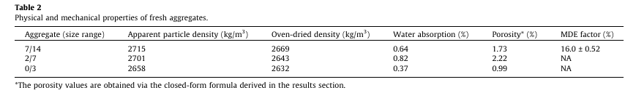

**Aggregate size used:-**

1. Upon completion of mixing, representative samples from the fresh base concrete mixture are taken and moist cured inside three 15*15*15cm 3cubicspecimensfor 28 days and tested for their compressive strength per EN 12390-3 (28-day compressive strength = 57.6 MPa).
2. However, due to lack of access to such types of crushers, the rubbles are crushed to aggregates only using a laboratory jaw crusher. The crusher opening is first set at 10 mm opening and all rubbles are passed through.
3. Resulting grains are crushed once more at 8.5 mm opening.
4. The obtained RCA is screened for the passing of 3 mm.
5. The experimental program is geared towards studying the effects of carbonation on the properties of the >3 mm fraction.
6. The grains are immediately washed after crushing, dried and stored for carbonation procedures.

**Different conditions for carbonation:-**

Five variables are defined and investigated in this research as follow.

1. RCA Moisture condition (‘‘Wet”, ‘‘Preconditioned”, ‘‘Air dried” and ‘‘Oven-dried”).
2. Relative humidity of the carbonation atmosphere (with or without boosting to saturation; referred to as ‘‘Boosted” or ‘‘Not boosted”).
3. CO2 pressure (1 bar or 5 bars).
4. Temperature (20 C or 60 C).
5. Carbonation Duration (1 h, 4 h or 24 h).

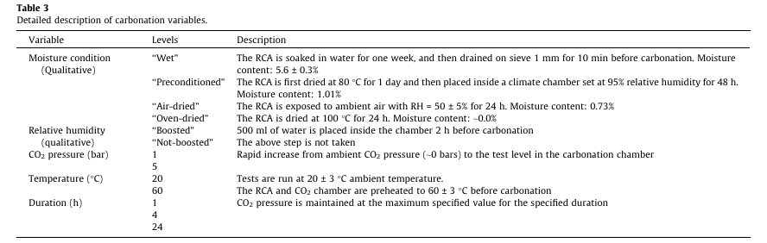

Carbonation procedure :-

Steps ;

1. Each recipe of carbonation is initiated by first adjusting the moisture condition.
2. The samples and the carbonation chamber are then brought to the test temperature two hours before the test.
3. Next, a nylon tray containing 500ml of water is placed inside the chamber in the case of ‘‘Boosted” experiments two hours in advance.
4. The samples are then placed inside the chamber and the carbonation is initiated by quickly injecting CO2 into the chamber to achieve the designated CO2pressure.
5. The pressure is preserved at that level for the specified duration and finally released and the chamber is flushed with nitrogen for 2min.
6. Upon completion of carbonation the samples are taken out and dried at 80 C in a ventilated oven for 24h to remove all the water trappedor generated during carbonation.